15/01/22
THM 415: Finance
Final Exam Answer Sheet
1. Why loan obtained from financial institutions is referred to as private debt? (2 Points)
A loan obtained from financial institution is referred to as a private debt since such a transaction involves only two parties (i.e. only lender and borrower).
2. The following depicts Corporate Bonds Spread Table:
Can Corporation is considering issuing bonds that will mature in 30 years with 4.04 % annual coupon rate. The interest will be paid quarterly. Can Corporation is hoping to get a BBB+ rating on its bonds. However Can Corporation is not sure whether the new bonds will receive that very rating.
- What is the price of Can Corporation bond? (1 Point)
According to the above Corporate Bonds Spread Table, the yield to maturity on a BBB+ rated 30-year bonds shall be 3.12 % + 3.33 % = 6.45 %. Therefore, the price of Can Corporation bond shall be:
- Bond Price (BBB+ rating) = - PV (6.45%/4, 30*4, (1000*4.04%)/4, 1000) = $ 681.16.
- What is the price of the bond if it gets a BBB- rating? (1 Point)
According to the above Corporate Bonds Spread Table, the yield to maturity on a BBB- rated 30-year bonds shall be 4.28 % + 3.33 % = 7.61 %. Therefore, the price of Can Corporation bond shall be:
- Bond Price (BBB- rating) = - PV (7.61%/4, 30*4, (1000*4.04%)/4, 1000) = $ 579.76.
3. Bozdoğan Company’s bonds mature in 27 years time and promise to pay 8.53 % coupon interest monthly. Suppose you purchase the bonds for $ 1,205.53.
a) What is Bozdoğan’s Company’s promised yield to maturity? (1 Point)
- Promised Yield to Maturity = Rate (27 * 12, (1000 * 8.53 %) / 12, -1205.53, 1000) ≈ 0.57 %.
Since this promised rate is a monthly rate, the promised yield to maturity shall be 0.57% * 12 = 6.86%.
b) Assume there is a 58 % probability of default on this bond and if the bond defaults, the bondholders will receive only 75 % of the principal and interest owed. What is the expected yield to maturity on this bond? (2 Points)
In case of default, I will get only 75 % of the principle (i.e. 75 % * 1,000 = $ 750) and 75 % of the payment (i.e. 75 % * (1,000 * 8.53 %) / 12 ≈ $ 5.33125). Therefore, Yield to Maturity (Default) = Rate (27 * 12, 5.33125, -1205.53, 750) * 2 ≈ 0.38 % * 12 = 4.60 %.
- Expected Yield to Maturity = (42 % * 6.86 %) + (58 % * 4.60 %) = 5.55 %.
4. Serdar Corporation is considering three mutual exclusive investments. The projects’ expected net cash flows are as follows:
a) What is the Net Present Value of Projects A, B and C at an appropriate discount rate of 5.05%? (1.50 Point)
- NPV (Project A) = NPV (5.05%, 12553, 13897, 17234, -1903, 7052, -734, 10500, 12500, 14500, -903, 8750, 10750, 12065, -2423, -718, 3325, 4053) – 62354 = $ 24,186.10.
- NPV (Project B) = NPV (5.05%, 5500, 7500, 9500, -2568, 7750, 9750, -7632, 2403, 4403, 5403, 6403, 7403) – 22587 = $ 19,008.27.
- NPV (Project C) = NPV (5.05%, -2022, 3613, 5613, -2453, 5894, 7894, 9945) – 15784 = $ 11,423.56.
- What is the Equivalent Annual Cost of Projects A, B and C? (1.50 Point)
- EAC (Project A) = PMT (5.05%, 17,-24186.10, 0) = $ 2,153.31.
- EAC (Project B) = PMT (5.05%, 12,-19008.27, 0) = $ 2,150.67.
- EAC (Project C) = PMT (5.05%, 8,-11423.56, 0) = $ 1,771.05.
- What are the Payback Periods for Project A, B and C? (1.50 Points)
- Payback Period (Project A) = 7.30 Years.
- Payback Period (Project B) = 4.34 Years.
- Payback Period (Project C) = 5.58 Years.
- What are the MIRR’s for Project A, B and C? (3 Points)
- MIRR (Project A) = IRR (-66573.08, 12553, 13897, 17234, 0, 7052, 0, 10500, 12500, 14500, 0, 8750, 10750, 12065, 0, 0, 3325, 4053) = 10.76 %.
- MIRR (Project B) = IRR (-30101.56, 5500, 7500, 9500, 0, 7750, 9750, 0, 2403, 4403, 5403, 6403, 7403) = 15.66 %.
- MIRR (Project C) = IRR (-19626.22, 0, 3613, 5613, 0, 5894, 7894, 9945) = 14.90 %.
- Based on MIRR, which project shall be chosen? Why? (1 Point)
Based solely on MIRR (there are problems with rankings of the projects if we don’t use NPV though), project B shall be chosen because its MIRR (i.e. 15.66 %) is at the same time greater than discount rate (5.05 %) and the highest amongst other projects (all modified projects are conventional cash flow patterns).
5. Saatçı Company is considering an independent project. The project’s expected net cash flows are as follows:
a) Calculate project’s IRR. (1 Point)
- IRR (Project) = IRR (-300, 950, 75, -850) = 11.61 %.
b) Draw the NPV profile for the project starting with a discount rate of 00% and increments of 20 % until you reach a discount rate of 240 %. (3 Points)
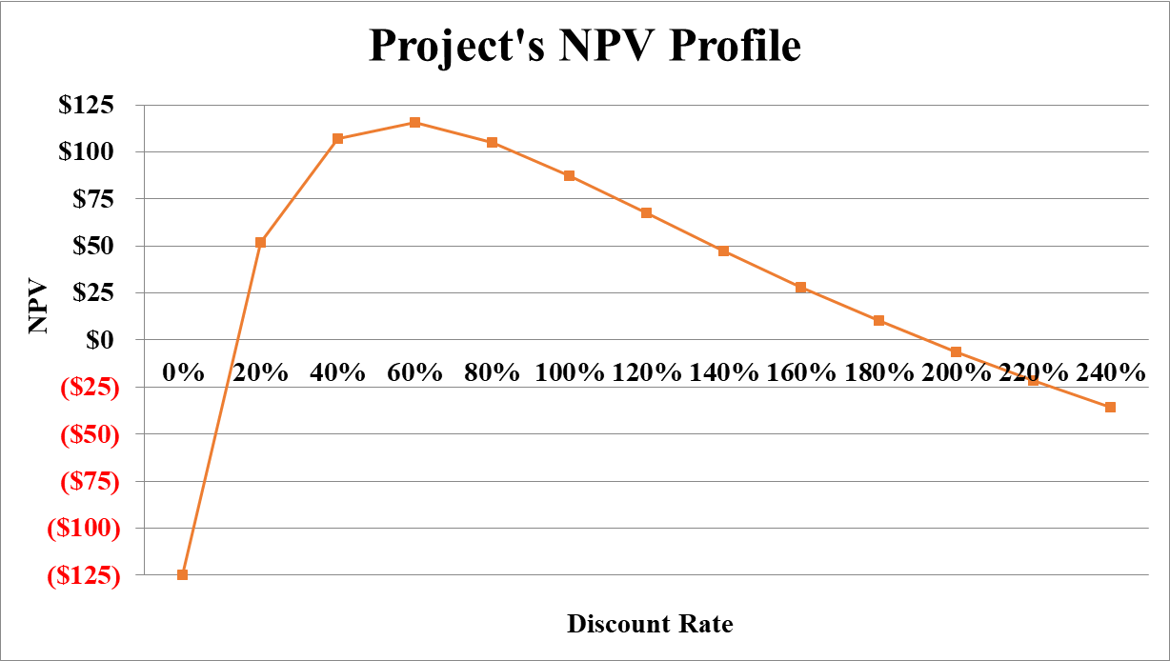
- Referring to the NPV Profile prepared in part b), what is the second IRR of the project? (2 Points)
The second IRR of the project occurs when the discount rate used is 192.00 %.
- What is your decision as far as to accept the project or reject it? (2 Points)
If the appropriate discount rate used to evaluate this very project is between 11.61 % and 192.00 %, accept the project. Otherwise, reject it.
6. Rıdvan Corporation, a firm in the 33 % marginal tax bracket with a 9.62 % required rate of return or discount rate, is considering a new project. This project involves the introduction of a new product. This project is expected to last 7 years and then, because this is somewhat of a fad product, it will be terminated. Moreover, the following bits of information are pertinent to this very new project:
- Cost of new plant and equipment: $ 4,250,000
- Shipping and installation costs: $ 375,062
Year | Units Sold
1 | 130,000
2 | 140,000
3 | 155,000
4 | 178,000
5 | 110,450
6 | 83,287
7 | 39,063
- Sales price per unit: $ 100 in year 1; expected to increase by 5 % on a yearly basis.
- Variable cost per unit: $ 55 in year1; expected to increase by 4 % on a yearly basis.
- Annual fixed costs: $ 3,675,000
- Working capital requirements: There will be an initial working capital requirement of $ 725,000 just to get production started. For each year, the total investment in net working capital will equal 9 % of the dollar value of sales for that year. In the final year, all working capital is liquidated at the termination of the project.
- The depreciation method: Use the simple straight line method over 7 years. It is assumed that the plant and equipment will have no salvage value after 7 years.
a) Determine the yearly net free cash flows associated with the project? (5 Points)
- Sketch a timeline for this new project? (0.50 Points)
- Calculate the Profitability Index of the project? (1 Point)
- Profitability Index = NPV (9.62 %, 1230288.64, 2086428.64, 2812434.84, 3866776.20, 2635537.62, 1395266.05, 398403.32) / (5350062) = 1.93 times.
- Shall the project be undertaken? Why? Why not? (1 Point)
Since profitability index of the estimated cash flows of the project is greater than 1, Rıdvan Corporation shall undertake the project.
7. De Souza Company is evaluating the purchase of Joseph Company. As a first step, De Souza Company wants to determine the Weighted Average Cost of Capital (WACC) (i.e. the appropriate discount rate to discount future estimated cash flows of Joseph Company). In this regard, De Souza Company determined the following dollar values pertinent to the right hand-side of the balance sheet of Joseph Company:
- What is the weight attributed to each source of capital? (1 Point)
First of all, not all liability and owners’ equity accounts are source of capital. We have to discard accounts payable and accrued expenses. Moreover, we have to look at market values instead of book values. In this regard, the weight attributed to each source of capital is depicted in the following table:

While short debt is entirely coming from a loan obtained from a private bank with a yearly interest rate of 6.16 %, long term debt is entirely coming from a 23-year issued bond (with 17 years to maturity) 7.14 % coupon rate and interest paid on a semi-annual basis. The bond price is currently traded at $ 1,009.99. Lastly suppose that marginal tax rate is 31.28 %.
- What is the cost of short-term debt? (1 Point)
- Cost of short-term debt = 6.16 % *(1 – 31.28 %) = 4.23 %.
- What is the cost of long-term debt? (1 Point)
- Yield to maturity = Rate (17*2, (1000*7.14%)/2, - 1009.99, 1000) * 2 = 3.52 % * 2 = 7.04 %.
- Cost of long-term debt = 7.04 % * (1 – 31.28 %) = 4.84 %.
- If preferred stocks issued by Joseph Company pays 7.46 % annual dividend and those very preferred stocks are traded currently at $ 903.03, what is the cost of preferred stock? (1 Point)
- Preferred stock dividend = 1,000 * 7.46 % = $ 74.60.
- Cost of preferred stock = (74.60 / 903.03) * 100 = 8.26 %.
Suppose that Joseph Company’s common stockholders have received dividends (pertaining to last year) of $ 6.75 per share and that very company’s common stocks are traded currently at $ 1,458.99 per share. Lastly, Joseph Company has paid the following dividends during the last 10 years:
- What is the cost of common stock? (1 Point)
- Growth Rate = 13.61 %
- Dividend 1 = 6.75 * (1 + 13.61 %) = $ 7.67
- Cost of common stock = (7.67 / 1458.99) + 13.61 % = 14.14 %.
- What is the Weighted Average Cost of Capital (WACC) of Joseph Company? (1 Point)
- Suppose De Souza Company is in need of $ 25,000,000 to finalize the acquisition of Joseph Company. Moreover, the amount needed will be financed 43 % through issuance of common stock and the remaining through issuance of bonds. Lastly, the intermediary bank responsible for the financing told that issue costs associated with bonds is 7.15 % while issue costs associated with equity is 9.43 %. What is the floatation cost associated with the acquisition of Joseph Company? (1 Point)
- Floatation cost of issuance of bonds = 7.15 %
- Weight of bonds in financing = 57 %
- Cost of issuance of common stock = 9.43 %
- Wight of common stocks in financing = 43 %
- Weighted average floatation cost = (57 % * 7.15 %) + (43 % * 9.43 %) = 8.139 %.
- Floatation cost associated with acquisition = 25,000,000 / (1 – 8.13 %) = $ 27,212,483.78.
De Souza Company uses Discounted Payback Period as the criterion to decide whether to finalize the purchase or not. Moreover, De Souza Company values 3.75 years as the cutoff period. Finally, the estimated cash flow generated from the purchase of Joseph Company for the next 10 years is depicted as the following:
- Shall the acquisition be finalized? Why? Why not? (Show all necessary calculations) (2 Points)
Since De Souza Company uses discounted payback period to evaluate its projects, we shall calculate the discounted payback period of Josef Company (bearing in mind that discount rate is 7.24 %):
- Discounted Payback Period (Josef Company) = 3.98 Years.
→ Since discounted payback period (i.e. 3.98 Years) is greater than cutoff period (i.e. 3.75 years), De Souza Company shall NOT finalize the acquisition of Josef Company.
Good Luck

